COMPUTER VISION
CCA 3: PRACTICAL CODING ASSIGNMENT
Image Restoration & Segmentation | Feature Extraction
Object Recognition | Motion Estimation

SUBMISSION DETAILS | INFORMATION
Student name | Anjali Chavan
PRN / Roll number | 1272251181
Programme | MCA
Course | Computer Vision – CCA 3
Programming language | Python
Execution platform | Google Colab
Submission date | 01/11/2026

A practical study of image understanding using computer vision techniques

Introduction
Computer Vision is a field of artificial intelligence that enables computers to interpret, analyse and extract meaningful information from images and videos. It combines image processing, pattern recognition and machine learning techniques to understand visual data.
This practical assignment explores core computer vision methods across Units 3, 4 and 5. The experiments were implemented in Python using OpenCV, NumPy, Matplotlib, scikit-image and Ultralytics YOLO, with Google Colab as the execution environment. The experiments use two photographs and a self-recorded video.
The work is organised into four tasks: image restoration and segmentation; feature extraction and image matching; object recognition using Viola–Jones and YOLO; and video motion estimation. The figures and numerical results in this report are taken from the uploaded completed notebook.

1. Assignment Objectives
- Introduce Gaussian and Salt-and-Pepper noise and restore images using median and Gaussian filtering.
- Evaluate restoration quality using Peak Signal-to-Noise Ratio (PSNR) and Structural Similarity Index (SSIM).
- Apply grayscale conversion, Otsu thresholding, morphological processing, Canny edge detection and watershed segmentation.
- Extract HOG and SIFT features and compare image matching under rotation and resizing.
- Compare Haar Cascade (Viola–Jones) face detection with YOLO object detection.
- Estimate video motion using frame differencing, MOG2 background subtraction and Lucas–Kanade optical flow.

2. Dataset Collection and Description

Input | File name | Recorded properties | Purpose
Original photograph | Image_1.jpg | 1600 × 1068 × 3 | Task 1 restoration/segmentation; Task 3 detection
Second photograph | Image_2.jpg | 1600 × 1068 × 3 | Task 2 feature extraction and matching
Self-recorded video | Sample_video.mp4 | 30 FPS; 300 frames; 10.0 s | Task 3 selected-frame detection; Task 4 motion estimation

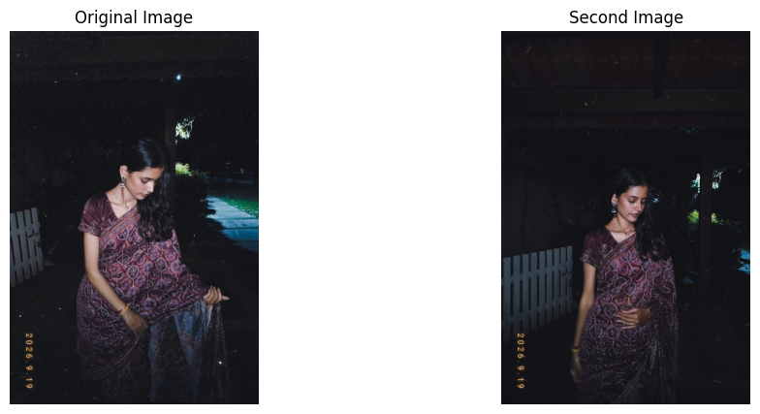
Figure 1. Input photographs used for feature extraction and matching.

3. Development Environment and Tools
Tool / library | Role in the project
Python / Google Colab | Programming language and cloud notebook execution environment.
OpenCV (cv2) | Image loading, filtering, thresholding, morphology, edge detection, watershed, feature detection and video processing.
NumPy | Array operations and pixel-level numerical processing.
Matplotlib | Visualisation and comparison of input and processed images.
scikit-image | PSNR/SSIM metrics and HOG feature extraction.
Ultralytics YOLO | Pretrained YOLOv8 Nano object detection model.

4. Project Organisation
The notebook separates the source dataset from generated outputs. The task output folders are organised as follows:
- dataset/images/ and dataset/videos/ – source photographs and video.
- outputs/task1_image_restoration/ and outputs/task1_segmentation/ – restoration and segmentation results.
- outputs/task2_feature_extraction/ – HOG and SIFT outputs.
- outputs/task3_object_detection/ – Viola–Jones and YOLO detection outputs.
- outputs/task4_motion_estimation/ – frame differencing, MOG2 and optical-flow outputs.

5. Task 1 — Image Restoration and Segmentation (Unit 3)
Aim: To study image restoration and segmentation by introducing controlled noise, applying spatial filters, evaluating image quality and identifying regions, boundaries and connected objects.

5.1 Image Restoration
Gaussian noise was generated with mean 0 and standard deviation 25. Salt-and-Pepper noise was added with a corruption probability of 0.04 (4%). Both noisy images were restored using a 5 × 5 median filter and a 5 × 5 Gaussian filter.
Method | Notebook parameter | Purpose
Gaussian noise | Mean = 0; standard deviation = 25 | Simulates random intensity variations.
Salt-and-Pepper noise | Probability = 0.04 | Introduces random black and white pixels.
Median filter | 5 × 5 kernel | Replaces each pixel with the neighbourhood median; useful for impulse noise.
Gaussian filter | 5 × 5 kernel; sigma set by OpenCV default | Smooths local intensity variations using a weighted average.

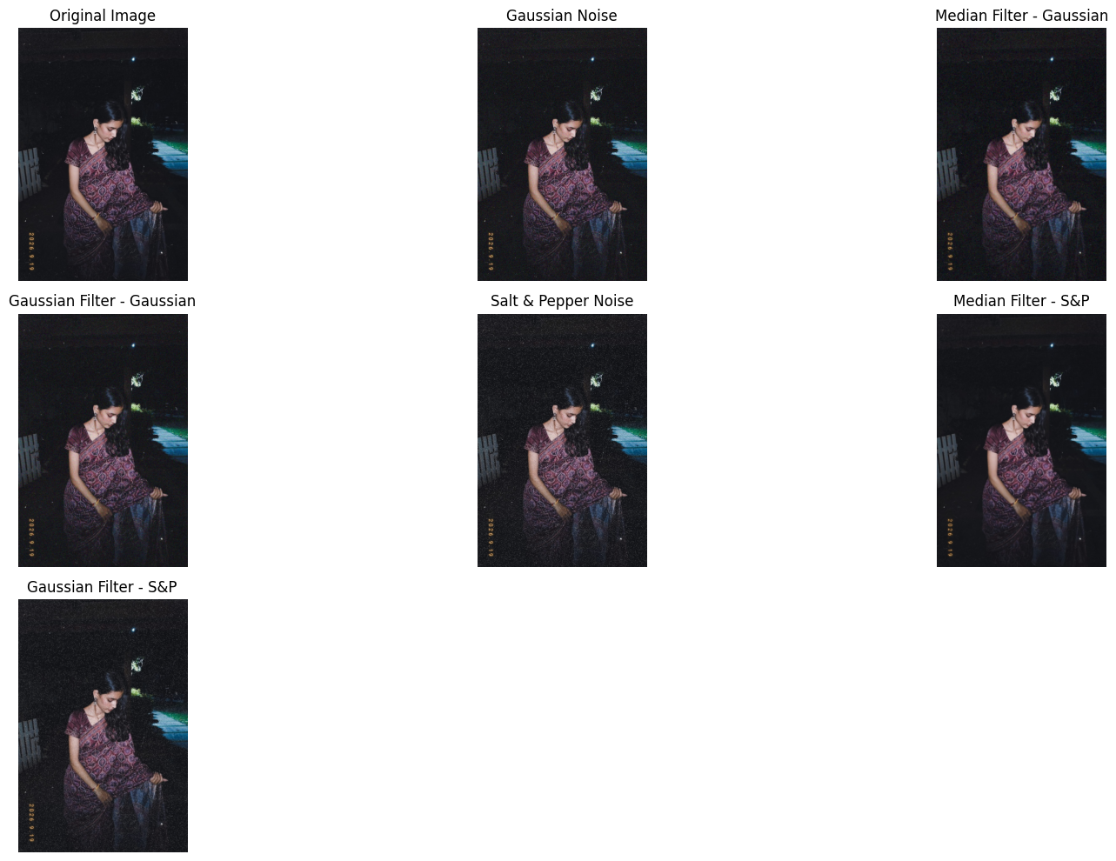
Figure 2. Original image, noisy inputs and filtered restoration outputs.

5.2 Quantitative Evaluation: PSNR and SSIM
PSNR measures reconstruction error relative to the clean reference image; higher values indicate lower pixel-level error. SSIM compares luminance, contrast and structure; values closer to 1 indicate greater structural similarity.
Noise type | Restoration method | PSNR (dB) | SSIM
Gaussian | Median 5 × 5 | 27.05 | 0.6543
Gaussian | Gaussian 5 × 5 | 28.65 | 0.6977
Salt-and-Pepper | Median 5 × 5 | 28.59 | 0.8949
Salt-and-Pepper | Gaussian 5 × 5 | 26.69 | 0.6124

Result interpretation For Gaussian noise, the Gaussian filter achieved the higher PSNR and SSIM of the two tested filters. For Salt-and-Pepper noise, the median filter achieved the higher PSNR and SSIM. The best method therefore depended on the noise type.

5.3 Grayscale Conversion and Thresholding
The original photograph was converted to grayscale and segmented using Otsu's global thresholding. The automatically calculated threshold was 79.0.
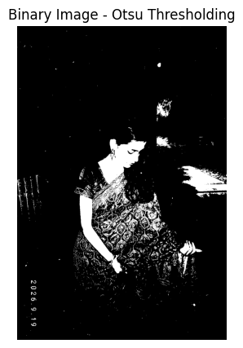
Figure 3. Binary image generated using Otsu thresholding (threshold = 79.0).

5.4 Morphological Processing
A 5 × 5 structuring element was used to perform erosion, dilation, opening and closing on the binary image. Erosion shrinks foreground regions; dilation expands them; opening is erosion followed by dilation; closing is dilation followed by erosion.
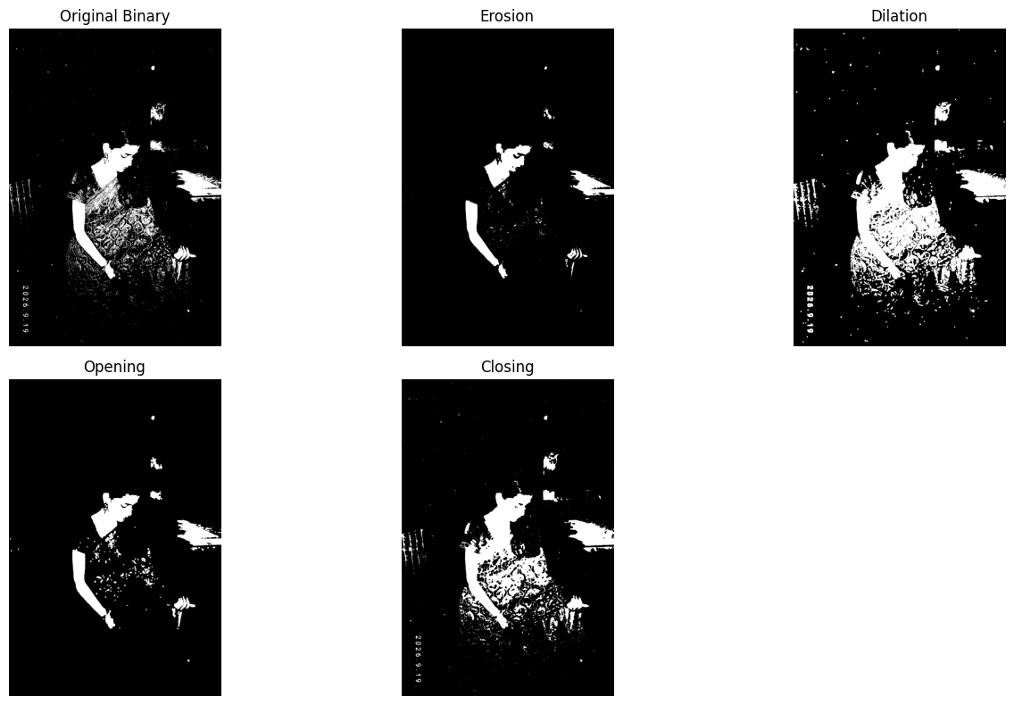
Figure 4. Binary input and the four morphological outputs.

5.5 Canny Edge Detection
Canny edge detection was applied to the grayscale image using a lower threshold of 100 and an upper threshold of 200.
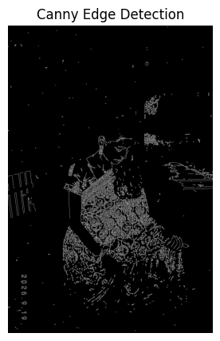
Figure 5. Canny edge map using thresholds 100 and 200.

5.6 Watershed Segmentation
Watershed segmentation was performed using morphological opening, dilation for the sure-background region, distance transformation, foreground marker generation and marker-based watershed processing. The notebook reported 4 foreground labels.
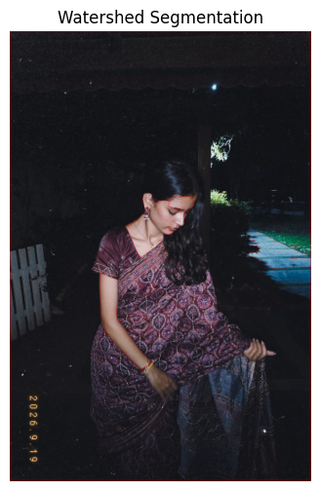
Figure 6. Watershed segmentation pipeline and boundary visualisation.
Task 1 conclusion The experiment demonstrated noise-specific restoration behaviour: Gaussian filtering performed better for the tested Gaussian noise, while median filtering performed better for Salt-and-Pepper noise. Otsu thresholding selected a threshold of 79.0; the notebook also produced morphology, Canny and watershed outputs. The watershed run reported four foreground labels.

6. Task 2 — Feature Extraction and Image Matching (Unit 4)
Aim: To extract visual descriptors from two photographs, match corresponding local features and examine the effect of rotation and resizing on SIFT matching.

6.1 Histogram of Oriented Gradients (HOG)
HOG describes local object shape and structure by computing gradient orientations. The notebook used 9 orientations, 8 × 8 pixels per cell and 2 × 2 cells per block.
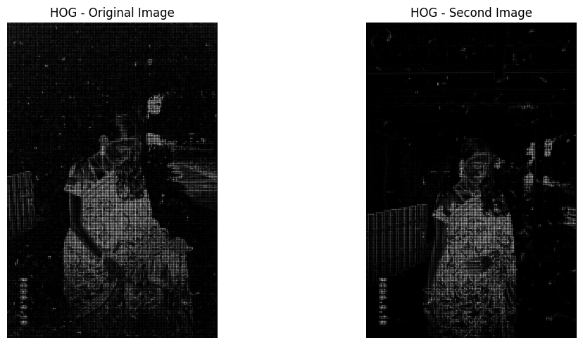
Figure 7. HOG visualisations for the original and second photographs.
Measurement | Original photograph | Second photograph
Image dimensions | 1600 × 1068 × 3 | 1600 × 1068 × 3
HOG feature-vector length | 945,648 | 945,648

6.2 SIFT Keypoint Detection
SIFT (Scale-Invariant Feature Transform) detects distinctive local keypoints and computes descriptors for matching. OpenCV's SIFT detector identified 4,051 keypoints in the original photograph and 2,263 in the second photograph.
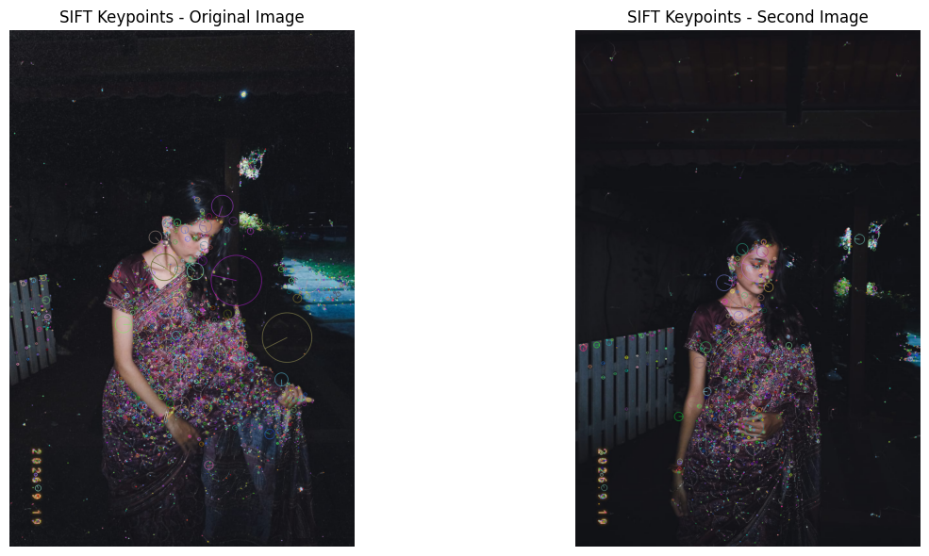
Figure 8. SIFT keypoints detected in both photographs.

6.3 SIFT Feature Matching
A Brute Force matcher with k-nearest-neighbour matching (k = 2) was used. Lowe's ratio test with a threshold of 0.75 retained the more distinctive matches.
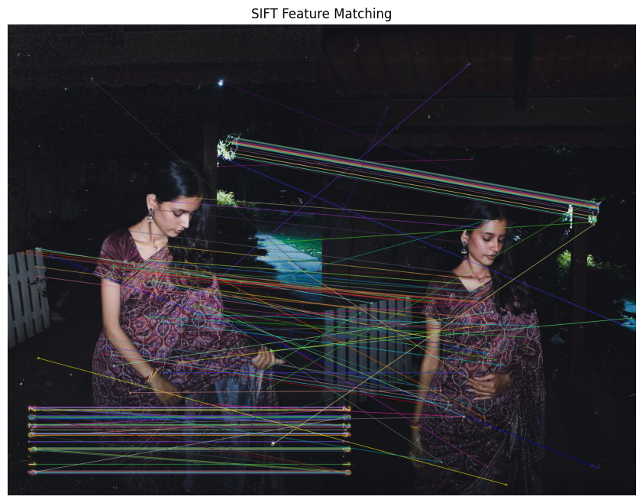
Figure 9. SIFT feature correspondences between the two photographs.
Matching experiment | Good matches
Original vs. second photograph | 186
Second photograph rotated by 45° | 150
Second photograph resized to 50% | 101

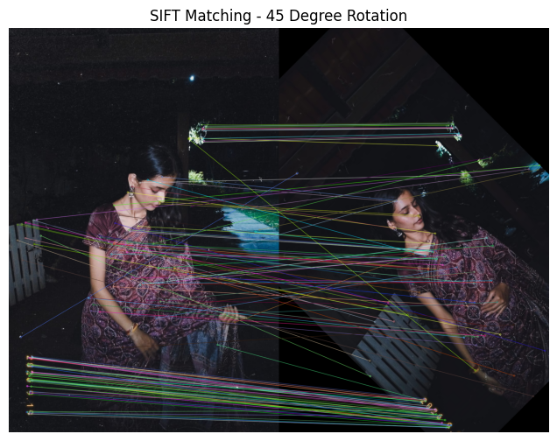
Figure 10. SIFT matching after rotating the second photograph by 45°.
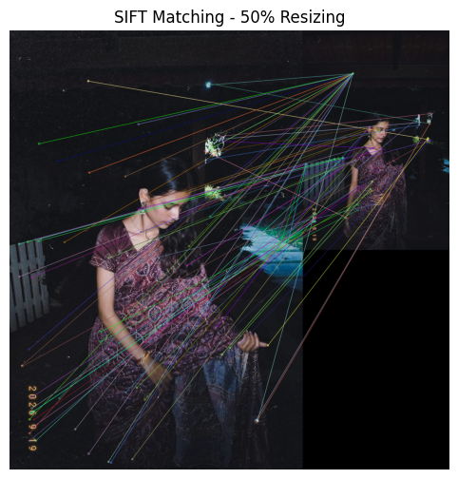
Figure 11. SIFT matching after resizing the second photograph to 50%.
Task 2 conclusion Both photographs produced HOG vectors of equal length. SIFT detected 4,051 and 2,263 keypoints, respectively. The original pair produced 186 good matches; this decreased to 150 after 45° rotation and 101 after 50% resizing. SIFT continued to find correspondences after both transformations, although the number of accepted matches decreased.

7. Task 3 — Object Recognition Using Viola–Jones and YOLO (Unit 5)
Aim: To apply a Haar Cascade face detector and a pretrained YOLO model, and inspect object-detection results on a photograph and a selected video frame.

7.1 Viola–Jones Face Detection
The notebook used OpenCV's pretrained haarcascade_frontalface_default.xml classifier. The photograph was converted to grayscale and scanned using detectMultiScale with scaleFactor 1.1, minNeighbors 5 and minimum size 30 × 30 pixels.
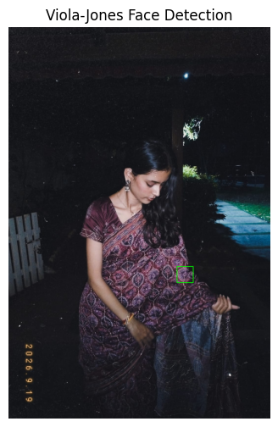
Figure 12. Viola–Jones Haar Cascade face detection.
Observed result The classifier detected 1 face in the input photograph.

7.2 YOLOv8 Nano Object Detection
The pretrained YOLOv8 Nano model (yolov8n.pt) was loaded through Ultralytics and run on the original photograph with a confidence threshold of 0.25.
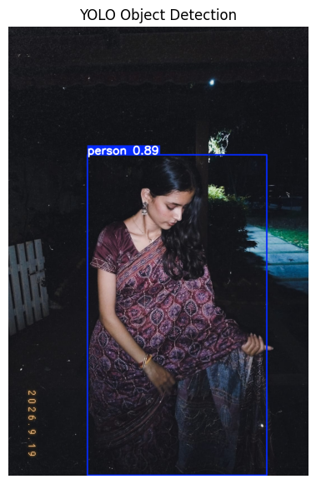
Figure 13. YOLOv8 Nano detection on the original photograph.
Input | Detected class | Detections | Confidence
Original photograph | person | 1 | 0.894 (89.4%)
Middle frame of video | sports ball | 1 | 0.293 (29.3%)

7.3 YOLO Detection on a Video Frame
The notebook selected the middle frame of the 300-frame video and applied the same YOLO model with a 0.25 confidence threshold. One sports ball was reported with a confidence score of 0.293 (29.3%). This is a relatively low-confidence detection and should be interpreted cautiously.
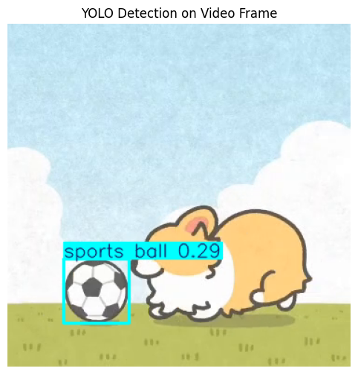
Figure 14. YOLOv8 Nano output on the selected middle video frame.

7.4 Method Comparison
Aspect | Viola–Jones | YOLOv8 Nano
Approach | Haar Cascade classifier | Pretrained deep-learning detector
Use in this experiment | Frontal-face detection | General object-category detection
Observed photograph result | 1 face | 1 person; confidence 89.4%
Confidence output | No confidence score reported by this code | Confidence score reported for each detection

Task 3 conclusion Viola–Jones detected one face in the photograph. YOLOv8 Nano detected one person in the photograph at 89.4% confidence and one sports ball in the selected video frame at 29.3% confidence. The two photograph results are not directly equivalent because the Viola–Jones experiment was configured for face detection, while YOLO reports general object classes.

8. Task 4 — Motion Estimation (Unit 5)
Aim: To detect changes and estimate movement in the self-recorded video using frame differencing, MOG2 background subtraction and Lucas–Kanade optical flow.
Video properties recorded by the notebook: 30 FPS, 300 frames and 10.0 seconds.

8.1 Frame Differencing
Frame differencing calculates the absolute pixel-wise difference between two grayscale frames. The notebook compared frame 0 and frame 15, applied a 5 × 5 Gaussian blur and thresholded the difference at 15 to highlight changed regions.
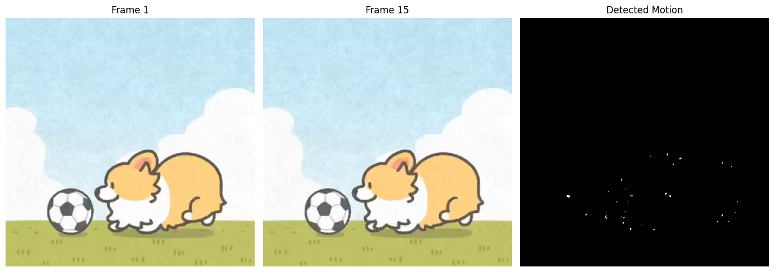
Figure 15. Frame 1, frame 15 and the detected motion mask.
Observation: The difference image showed small white regions where pixel values changed. The detected regions were sparse, indicating relatively small visual differences between the selected frames.

8.2 Background Subtraction using MOG2
The MOG2 (Mixture of Gaussians) background subtractor models the background over time and classifies pixels as foreground or background. The notebook used history = 100, varThreshold = 25 and detectShadows = True, and processed the full video.
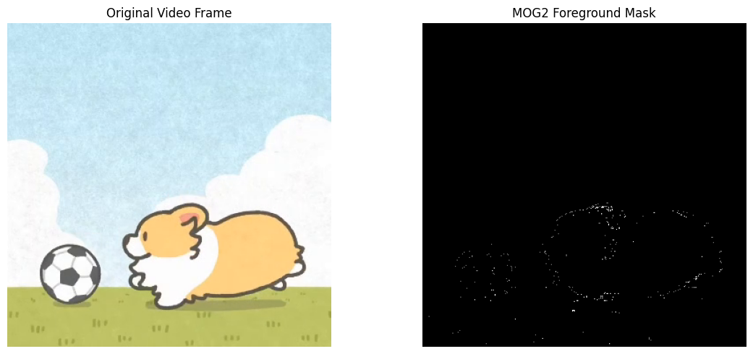
Figure 16. Final video frame and MOG2 foreground mask.
Observed result MOG2 processed all 300 frames. The final foreground mask shown is the output after processing the video sequentially.

8.3 Lucas–Kanade Optical Flow
Shi–Tomasi corner detection selected feature points in the first frame. The pyramidal Lucas–Kanade method then estimated their displacement between the first and next frame.
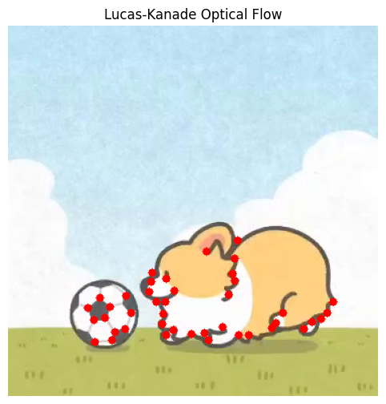
Figure 17. Lucas–Kanade tracked feature points and motion vectors.
Measurement | Result
Feature points detected | 42
Successfully tracked points | 42
Tracking success | 100%

8.4 Comparison of Motion Estimation Methods
Technique | What it measures | Observed notebook result
Frame differencing | Pixel changes between two selected frames | Small motion regions detected between frames 0 and 15.
MOG2 background subtraction | Foreground relative to a learned background | All 300 frames processed; foreground mask generated.
Lucas–Kanade optical flow | Displacement of selected feature points | 42 of 42 points tracked between two consecutive frames.

Task 4 conclusion The three techniques provided complementary views of motion. Frame differencing highlighted changes between selected frames, MOG2 generated a foreground mask after processing all 300 frames, and Lucas–Kanade successfully tracked all 42 selected points between the first two frames.

9. Overall Conclusion
The CCA 3 practical assignment implemented four groups of computer vision techniques using Python in Google Colab. In Task 1, restoration metrics showed that the Gaussian filter performed better for the tested Gaussian noise, while the median filter performed better for Salt-and-Pepper noise. Otsu thresholding, morphological operations, Canny edge detection and watershed segmentation were also executed.
In Task 2, HOG features were extracted from both photographs and SIFT was used to detect keypoints and match local descriptors. Matching remained possible after rotation and resizing, although the number of accepted matches decreased. In Task 3, Viola–Jones detected one face and YOLO detected a person in the photograph and a sports ball in the selected video frame. In Task 4, frame differencing, MOG2 and Lucas–Kanade demonstrated pixel-change detection, foreground extraction and feature-point tracking.
The experiments illustrate that computer vision tasks require different methods depending on the visual problem. The quantitative results and figures documented here are the outputs recorded in the submitted notebook. They describe performance on the selected inputs and should not be interpreted as general accuracy benchmarks.

